Lab: Referer-based access control
Lab Report
Prepared by: Nihar Mane

INDEX
1. Introduction....................................................................................... 2
2. Executive Summary............................................................................. 2
3. Scope................................................................................................. 2
4. Methodology and Root Cause.............................................................. 2
5. Step-by-Step Execution....................................................................... 3
6. Impact Assessment............................................................................. 10
7. Remediation....................................................................................... 10
8. Conclusion.......................................................................................... 11
9. References......................................................................................... 11

- Introduction
This lab continues the Week 2 authorization track of this portfolio, following directly from the concept-reference report on Authentication vs. Authorization, IDOR, and Horizontal/Vertical Access Control, and from the URL-Based Access Control lab. Where that lab exploited a mismatch between a front-end proxy and a back-end routing header, this lab targets a different—and equally common—flawed access control signal: the HTTP Referer header. The admin panel here restricts privileged actions by checking where the request appears to have come from, rather than verifying who the requester actually is.
The lab exposes an admin-only “upgrade user” action at /admin-roles. Genuine admin requests always carry a Referer header pointing back to the admin panel page, because the browser sends it automatically when a link on that page is followed. The application treats the presence of that header as proof of admin authorization—a classic case of context-dependent access control relying on a client-supplied signal instead of a server-side permission check.

- Summary
The target application gates the admin-only user-promotion endpoint (/admin-roles) on the presence of a specific Referer header value, rather than verifying the caller's session role. Because the Referer header is fully attacker-controlled when a request is crafted directly (e.g. via Burp Repeater rather than by clicking a link in the browser), a standard user's own valid session can be replayed against the admin endpoint with a forged Referer header and succeed. Logging in as wiener (a normal, non-admin user) and replaying an admin-captured request with wiener's own session cookie and the correct Referer value promoted wiener to administrator—with no admin credentials, no session hijacking, and no code execution required.

- Scope
Target: the PortSwigger Web Security Academy lab instance at *.web-security-academy.net provisioned for "referer-based access control.” Testing used only the credentials and functionality provided by the lab: the administrator: admin reference account (used to observe legitimate admin behaviour) and the wiener:peter attacker account (used to carry out the exploit). Tooling was limited to Burp Suite Community Edition (Proxy and Repeater) and Chrome DevTools for cookie inspection. All requests stayed within the lab's own domain and scope as defined by the Web Security Academy platform

- Methodology and Root Cause
Methodology: the admin promotion flow was first observed as a legitimate administrator to capture a valid, correctly-authorized request. That request was preserved in Burp Repeater as a baseline. A second browser session was then established as the low-privileged user wiener, and its session cookie was substituted into the preserved admin request — isolating whether the endpoint's authorization depended on the session (which it should) or on some other request attribute (which it did). The Referer header was then removed and reinstated in turn to confirm it was the actual authorization signal, before finally substituting the target username to complete the exploit.
Root cause: the /admin-roles endpoint infers administrator authorization from the presence of a Referer header pointing back to /admin, on the assumption that only a request originating from a link on the admin panel page could carry that value. This is a context-dependent access control relying on client-supplied metadata rather than a server-side session/role check. The Referer header is fully attacker-controlled in any request not generated by a real browser navigation — tools like Burp Repeater let an attacker set it to any value — so the “proof” the server is relying on proves nothing about the caller's actual privilege level. This matches the pattern described in Part 1 of this portfolio's access-control reference report: authorization decided by a signal the server does not actually control.
- Step-by-step execution

Step 1: Log in as the reference administrator.
Logged in to the lab using the provided reference credentials administrator: admin to observe the admin panel's legitimate behavior before attempting any bypass.

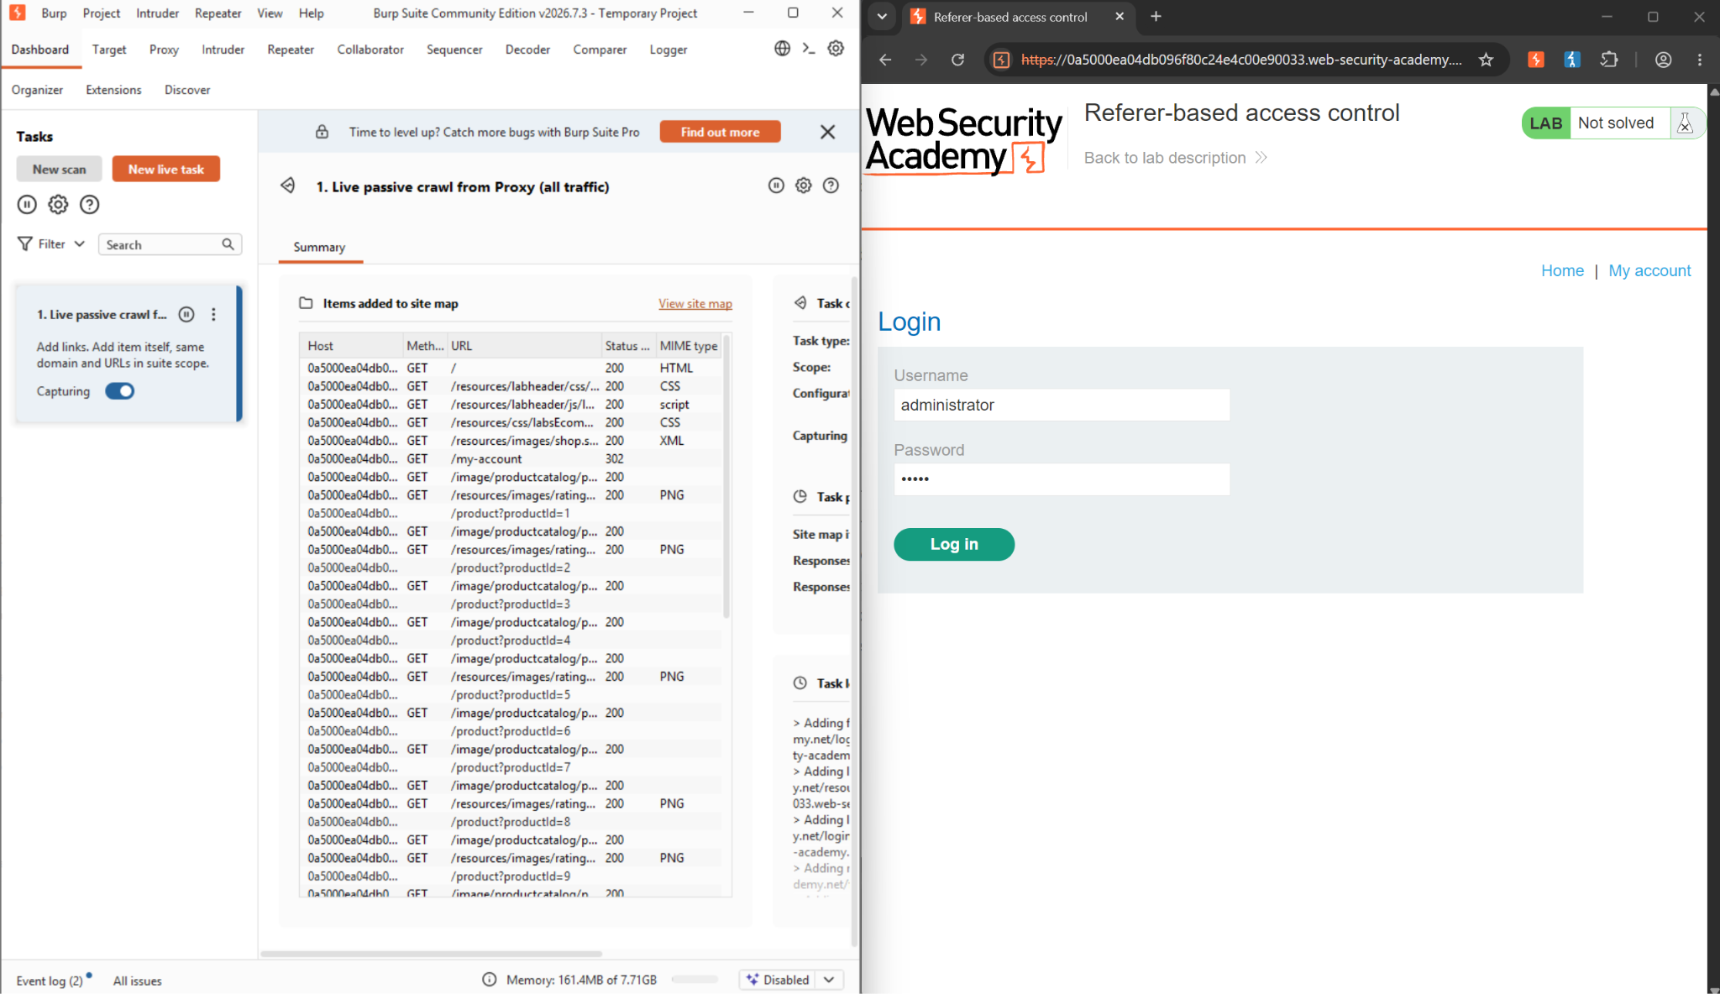
Figure 1: Logging in to the lab as the reference administrator account

Step 2: Promote carlos and capture the request
From the admin panel, selected carlos (NORMAL) and clicked “Upgrade user.” Burp's site map confirms the resulting request — GET /admin-roles?username=carlos&action=upgrade — returned a 302 redirect to /admin, and the panel now shows carlos as ADMIN, confirming the action succeeded while authenticated as a genuine administrator.

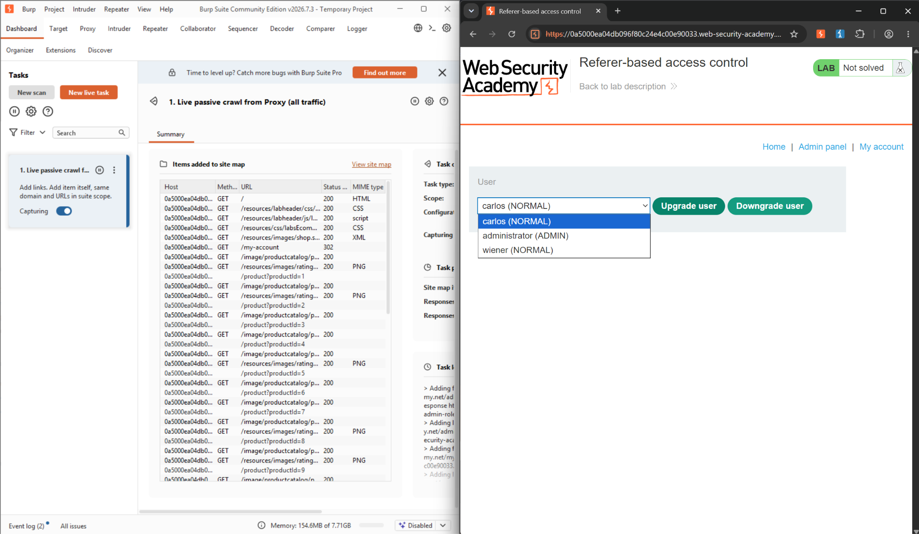
Figure 2: Admin panel: selecting carlos and clicking Upgrade user .

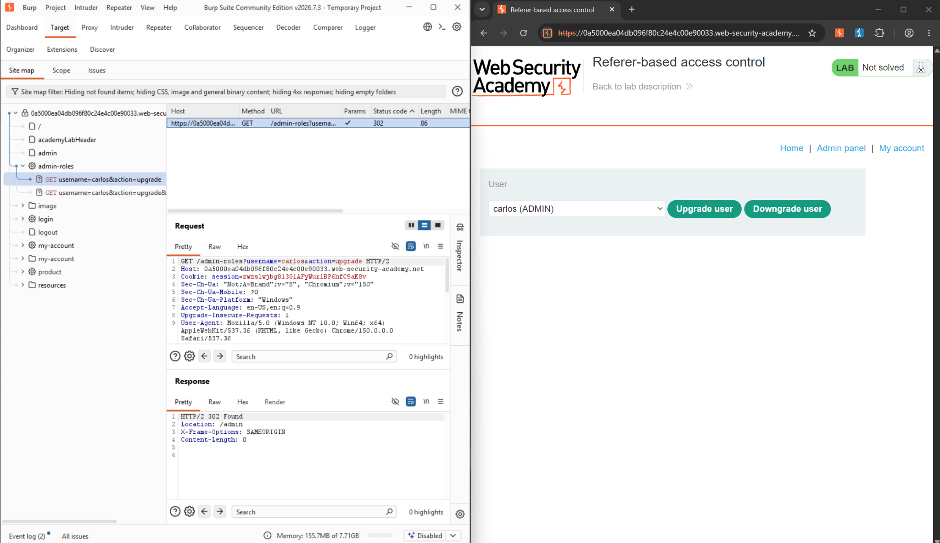
Figure 3: Burp site map showing the logged admin-roles upgrade request and carlos now listed as ADMIN .

Step 3: Send the captured request to Repeater
Right-clicked the logged admin-roles request in the site map and selected Send to Repeater, preserving the exact headers and cookie used for the successful, legitimately-authorized promotion so they could be tampered with safely.

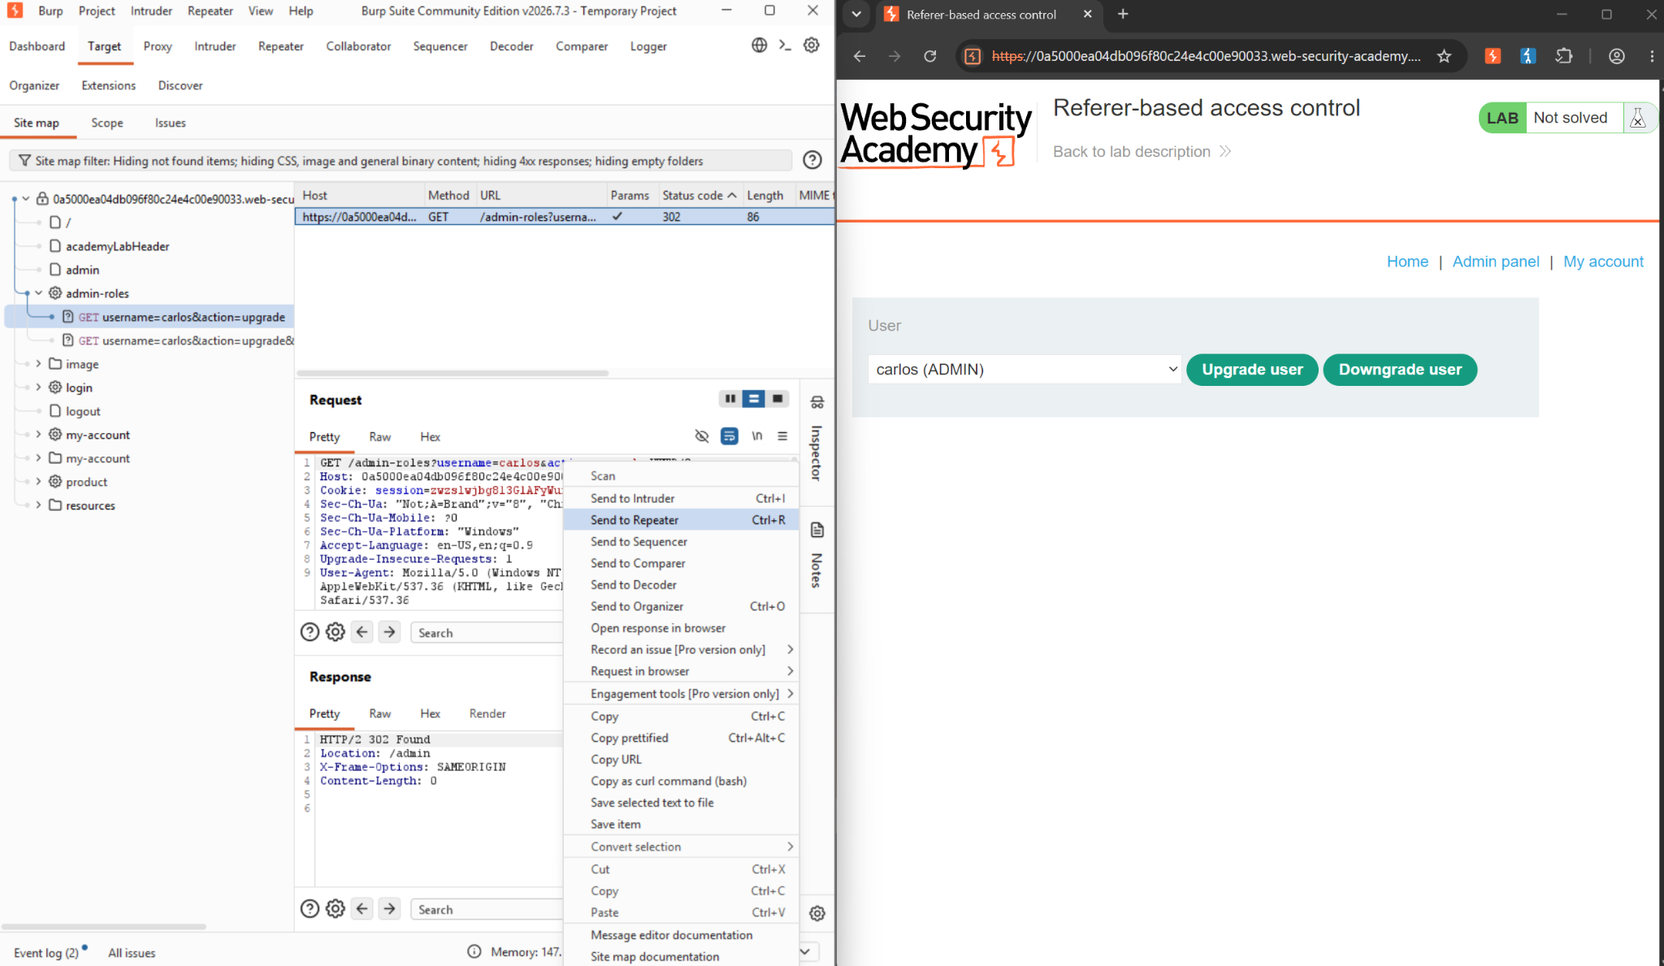
Figure 4: Sending the captured admin-roles request to Burp Repeater.

Step 4: Log out and log in as the low-privileged user
Logged out of the administrator account and logged back in using the non-admin credentials wiener:peter. The Repeater tab still holds the earlier admin request — including its Referer header — for comparison as the low-privileged session is established.
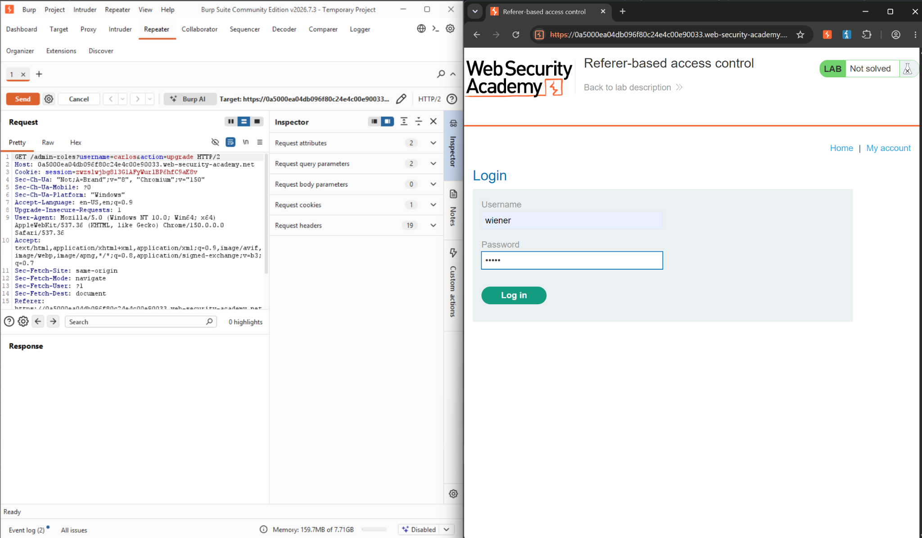
Figure 5: Logging in as the low-privileged user Wiener, with the admin request still held in Repeater.

Step 5: Retrieve wiener's session cookie
With DevTools open on the Application panel, copied the value of wiener's own session cookie from the My Account page, ready to substitute it into the preserved admin request in place of the administrator's session

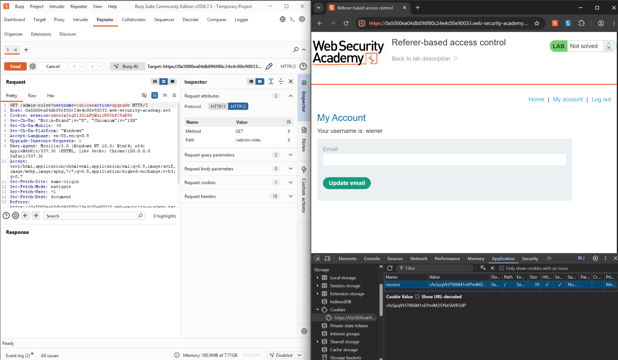
Figure 6: Copying wiener's session cookie value from Chrome DevTools.

Step 6: Replace the session cookie in the Repeater request
Pasted wiener's session cookie value over the administrator's session cookie in the Repeater request, so the request now carries wiener's own valid, low-privileged session alongside the admin request's original parameters and Referer header.
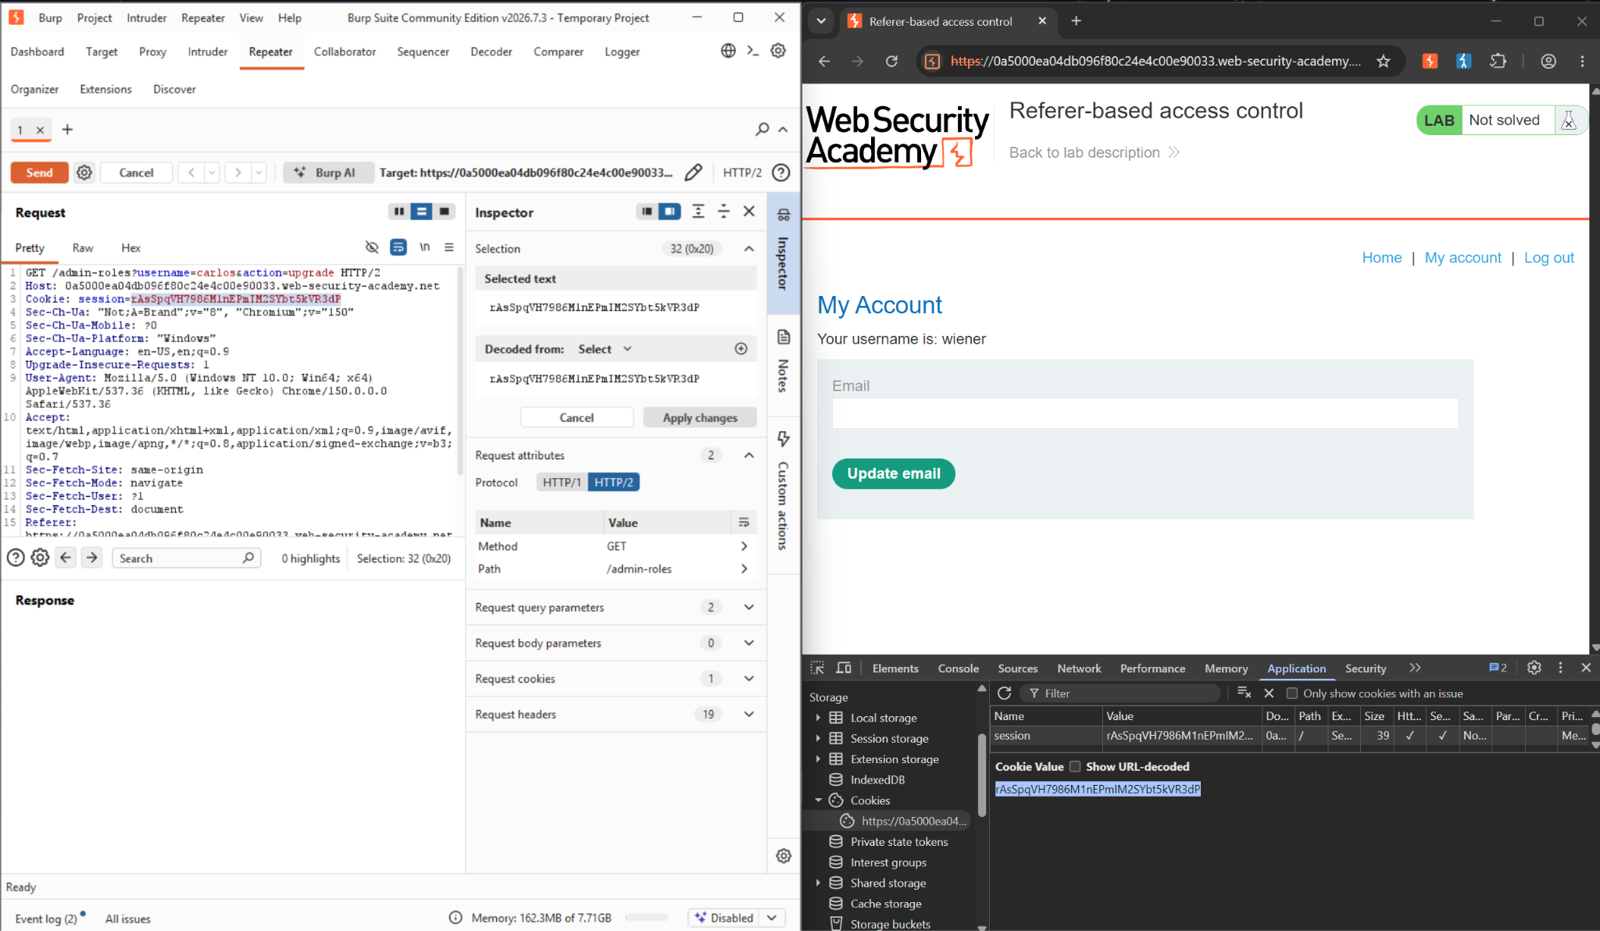
Figure 7: Replacing the administrator's session cookie with wiener's session cookie in Repeater.

Step 7: Remove the Referer header and test
Removed the Referer header entirely and sent the request (now authenticated as wiener, targeting username=carlos&action=upgrade). The server responded 401 Unauthorized — confirming the endpoint is actively checking for the Referer header, and that wiener's session alone is not sufficient to reach it.

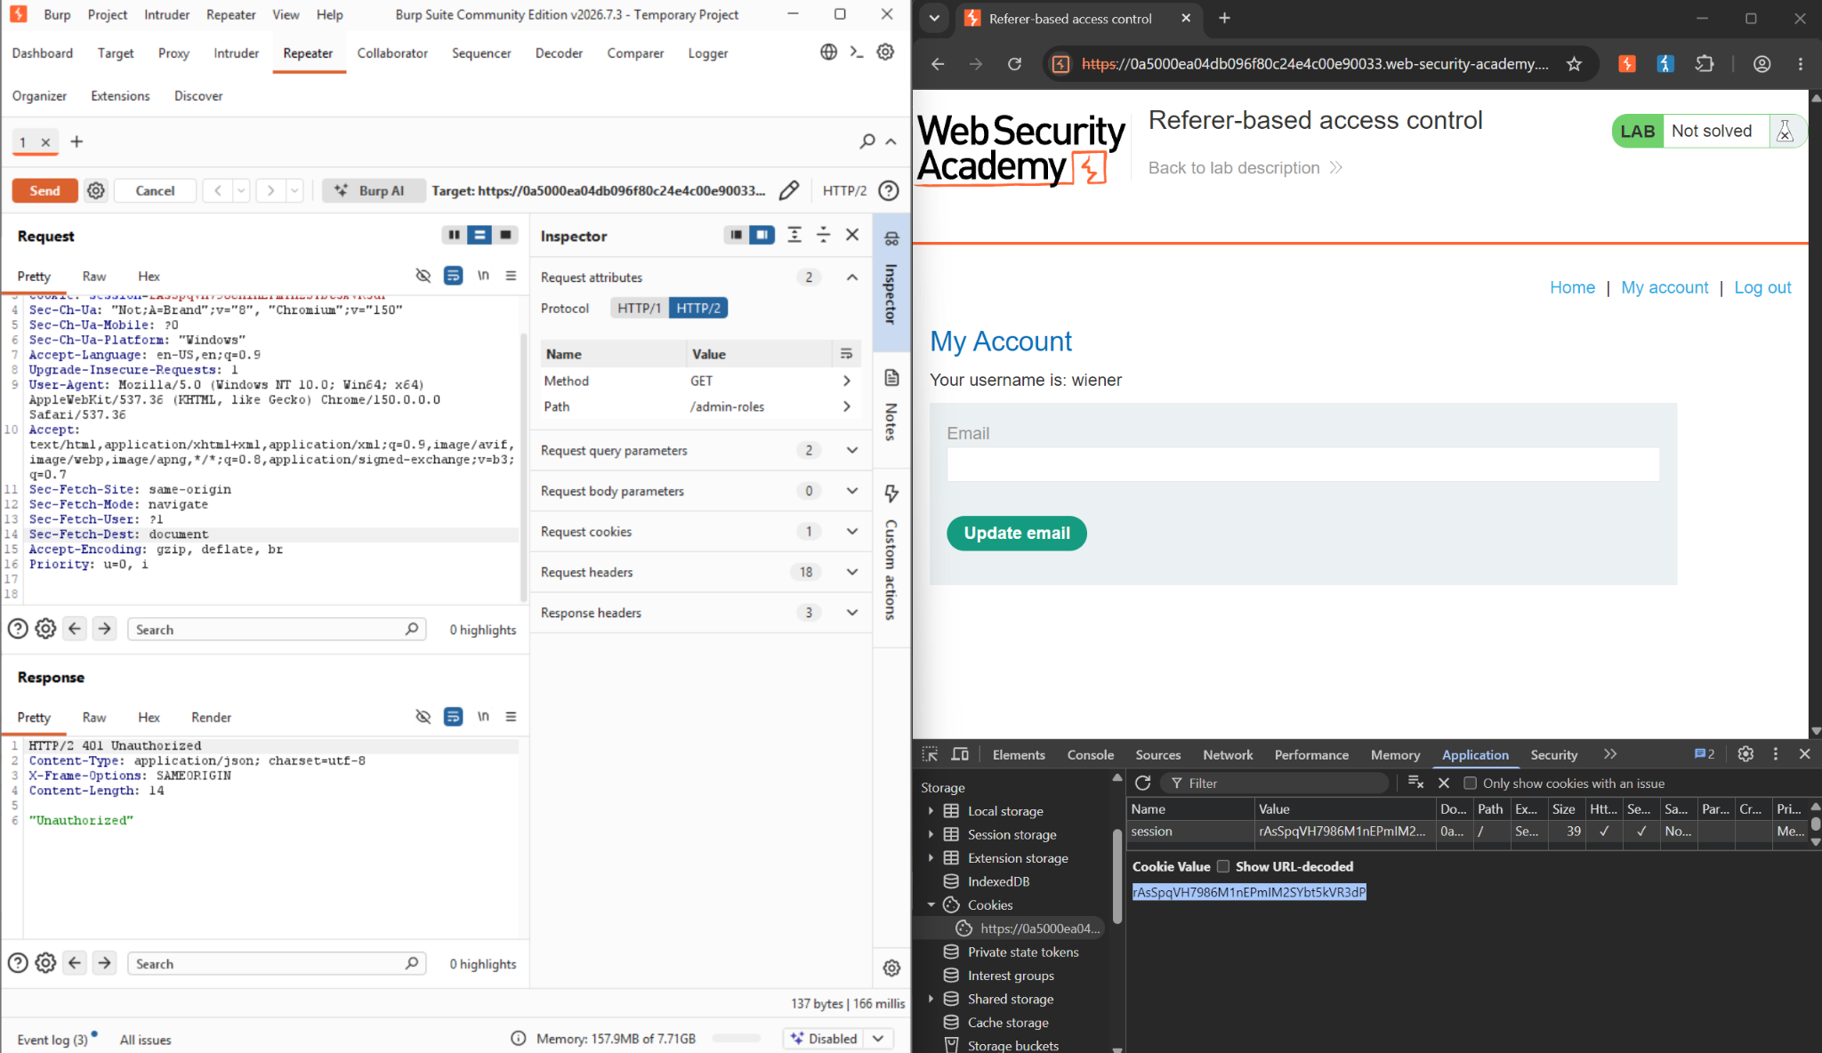
Figure 8: Request sent with wiener's session and no Referer header — 401 Unauthorized.

Step 8: Restore the Referer header
Re-added the Referer header with its original value pointing back to the admin panel (.../admin) while keeping wiener's session cookie in place, isolating the Referer header as the specific condition still to be tested.

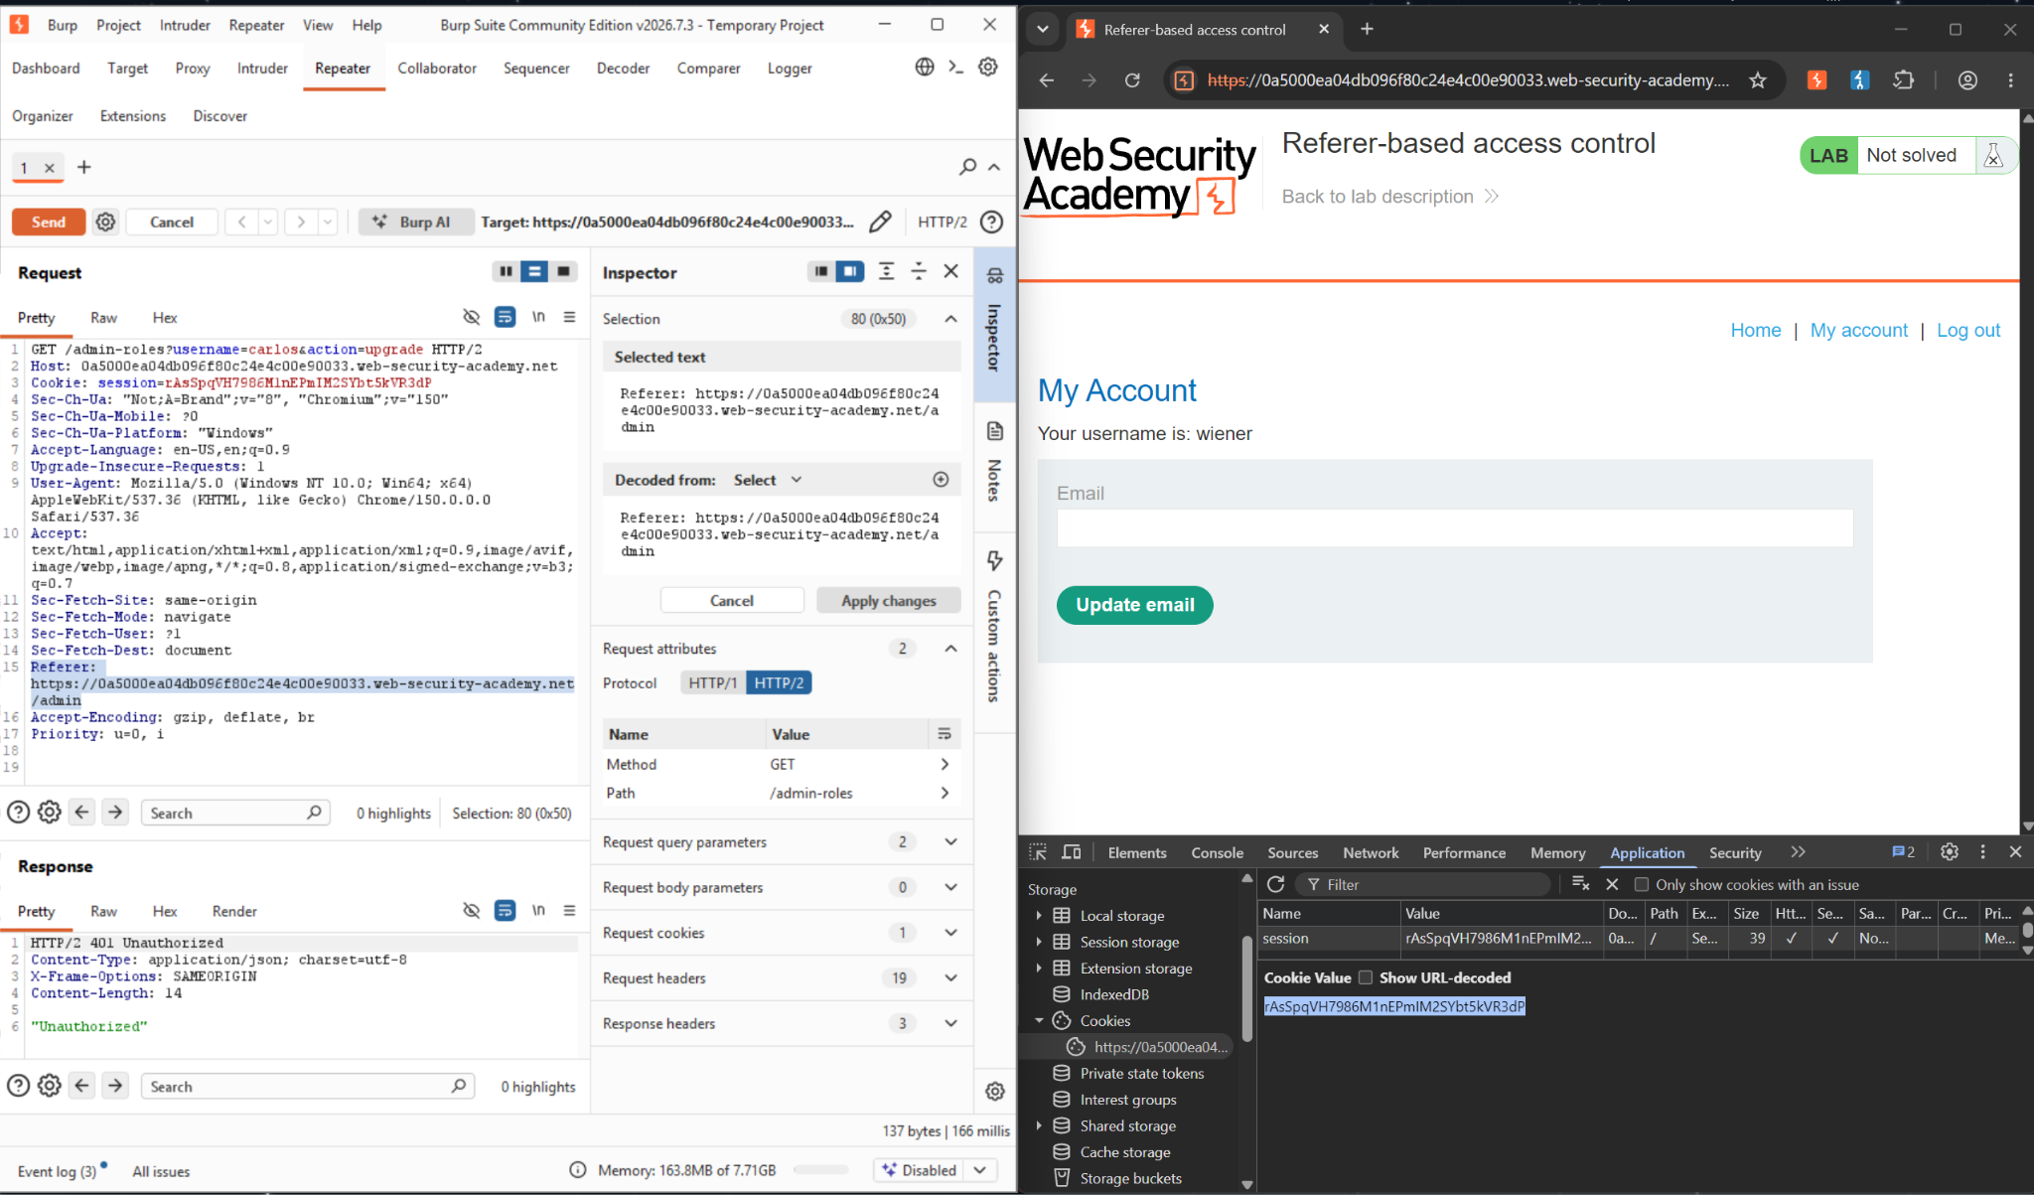
Figure 9: Restoring the Referer header pointing back to /admin

Step 9: Change the target username and replay
Changed the username parameter from carlos to wiener — self-targeting the promotion — and sent the request with wiener's session cookie and the restored Referer header intact. The server responded 302 Found, redirecting to /admin, and the lab banner confirms: “Congratulations, you solved the lab!” wiener was promoted to administrator using only their own low-privileged session and a forged Referer header .

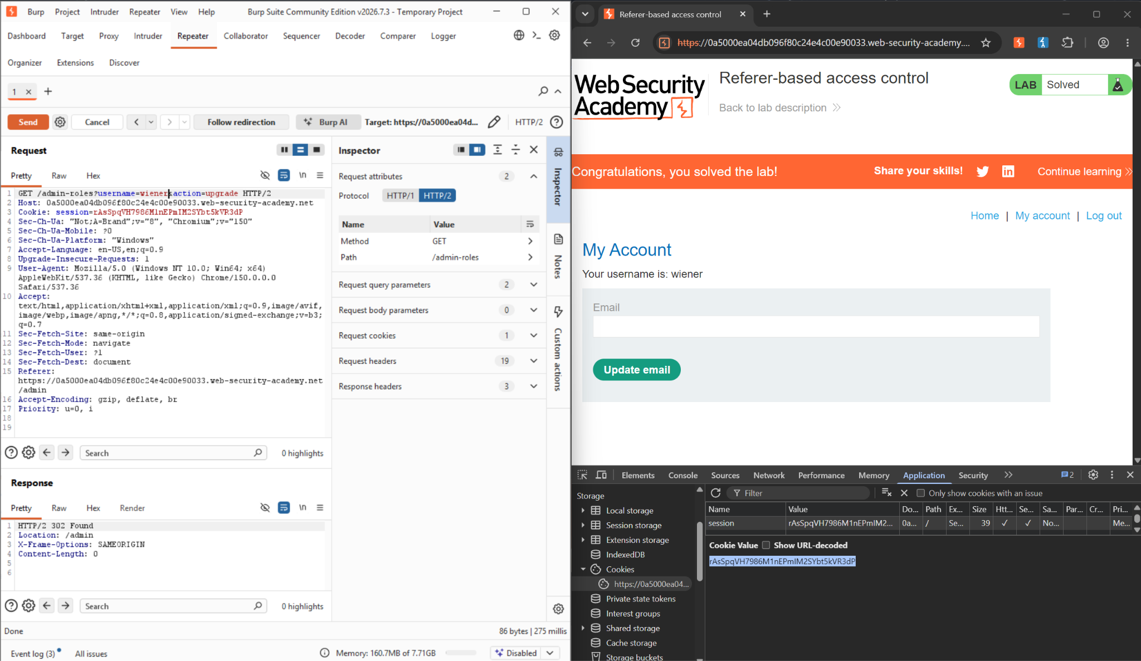
Figure 10: Final request with username=wiener and the Referer header restored — 302 Found, lab solved

- Impact Assessment
The impact is a complete, self-service vertical privilege escalation: any authenticated low-privileged user can promote their own account to administrator without ever possessing admin credentials, without session hijacking, and without any server-side vulnerability beyond a single misplaced authorization check. In a production application, the equivalent flaw would let any registered user grant themselves full administrative control—user management, data access, configuration changes—by simply crafting one request with a forged header.
Severity is high because the attack requires nothing beyond a standard, legitimately issued low-privilege session and a widely available tool (any intercepting proxy). No credential theft, no race condition, and no injection are needed—only the observation that the Referer header the server trusts is entirely attacker-controlled outside of normal browser navigation.

- Remediation
The Referer header must never be used as an authorization signal, since it is fully client-controlled and easily forged, omitted, or stripped by the browser depending on referrer policy:
• Enforce authorization server-side based on the authenticated session's role, verified against a trusted store (e.g. a database record or signed claim) — never based on request headers a client can set arbitrarily.
• Apply deny-by-default checks on every privileged endpoint (including /admin-roles) that explicitly confirm the caller's session carries an administrator role before executing the action.
• Treat the Referer header purely as a hint for analytics or UX (e.g. tailoring content), never as a security control, since it is not attacker-resistant by design.
• Log and alert on privilege-escalation attempts — requests to role-modifying endpoints from sessions that do not already hold the target role — to catch this pattern even if a similar flaw reappears elsewhere.
• Include automated authorization tests in CI that specifically attempt privileged actions using a low-privileged session with a forged Referer header, to catch regressions of this exact pattern.

- Conclusion
This lab is a direct, hands-on instance of the “context-dependent access control” failure mode described conceptually in this portfolio's access-control reference report: an application inferring authorization from something about the request's context (here, the Referer header) rather than from an explicit, server-side permission check tied to the authenticated session. It sits alongside the URL-Based Access Control lab as a second demonstration of the same underlying habit — trusting a client-supplied signal in place of verification — applied to a different mechanism. Together with the Week 1 Host Header family and the Week 2 authentication labs, the throughline holds: whichever layer of the request a server chooses to trust without verifying it, that trust becomes the exploit.

References
- Lab: Referer-based access control
https://portswigger.net/web-security/access-control/lab-referer-based-access-control

